**מדריך להפעלת רשת YOLOV4 על JETSON TX2:**

**דרישות:**

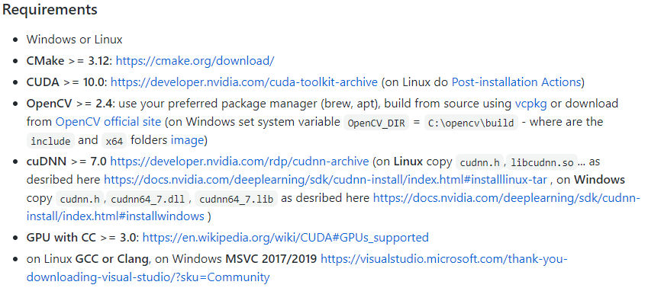

**הורדת הרשת:**

1. git clone <https://github.com/AlexeyAB/darknet.git>
2. git clone <https://github.com/avivpaskaro/drones_project.git>
3. Download weights into darknet folder-https://drive.google.com/file/d/1T3tEckYdOZ585USkCl28MaBdzEeON3Cz/view?usp=sharing
4. cp ./drones_project/* ./darknet

**הפעלת הרשת:**

1. cd darknet
2. make
3. chmod 777 darknet_run
4. ./darknet_run

פרמטרים לריצה, נמצאים בתוך הקובץ darknet_run:

--input - takes webcam number or video input path (webcam=0 if empty)

--out_filename - takes out video file name (not saved if empty)

--export_logname - takes out log file name

--weights - takes yolo weights path

--dont_show - hide window inference display

--config_file - takes path to config file

--data_file - takes path to data file

--thresh - takes value to remove detections with confidence below (thresh=0.25 if empty)